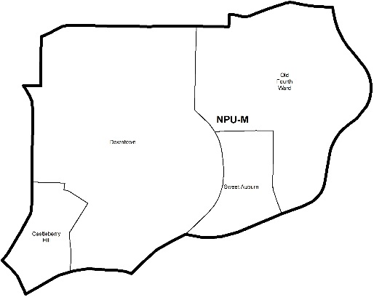

NEIGHBORHOOD PLANNING UNIT – M

MEETING INFO
Date & Time: Monday, July 23, 2018 – 6:15 PM
Location: Loudermilk Conference Center
40 Courtland Street NE Atlanta, GA 30303
CONTACT INFO
Derek Matory, NPU-M, Chairperson – (404) 784-0814 or chair@npumatlanta.org
Jon McKenley, City of Atlanta, Planner – (404) 546-0158 or jmckenley@AtlantaGa.Gov
Erica Pines, City of Atlanta, Asst. Director – (404) 546-0159 or epines@AtlantaGa.Gov
Keyetta Holmes, City of Atlanta, Interim Director – (404) 546-0166 or kmholmes@AtlantaGa.Gov

AGENDA
1. Opening Remarks/Introductions 6:22
2. Approval of Minutes Approved
3. Announcements
4. Reports from City Departmental Representatives
5. Comments from Elected Officials
6. Presentation(s)
Atlanta Bicycle Coalition: Sagirah Jones
7. Planner’s Report
- Zoning Ordinance Update Phase II
8. Committee Reports
9. Matters for Voting

Special Event Application(s) – MOSE
Be Out Day  Motion to Support: Approved | John Watson | Central Park | August 11, 2018
German Bierfest 2018  Motion to Support: Approved | Laura Valente | Woodruff Park | August 25, 2018
LudaFamDay  (Review and Comment Only) | Roberta Shields | Friendship Field | September 01, 2018
ONE Musicfest  Motion to Support: Approved | Josh Antenucci | Central Park | September 8-9, 2018

Liquor License Application(s) – LRB
Name of Business | Type of Business | Applicant | Property Address | Request
Field Day  Motion to Support: Approved | Restaurant | Owen C. Bouton | 668 Highland Avenue NE | Change of Ownership
Every Day  Motion to Support: Approved | Food Store | Owen C. Bouton | 670 Highland Avenue NE | Change of Ownership
Alter Ego Event Space  Motion to Support: Approved | Event Space | Al Cornelius | 419 Edgewood Avenue | New Business
The Ritz-Carlton, Atlanta (Atlanta Grill, Lobby Lounge, Club Level and Ballroom Basement)  Motion to Support: Approved | Hotel | Adam B. Tidd | 181 Peachtree Street NE | Change of Agent
CVS Pharmacy  Motion to Support: Approved | Retail Pharmacy | Jason McCrea | 235 Peachtree Street | Change of Agent

Board of Zoning Adjustment Application(s) – BZA
Application | Property Address | Public Hearing Date
V-18-188  Applicant seeks a variance from the zoning regulation to 1) allow a driveway/parking pad in the required front yard to exceed the 20 feet in width requirement to 23 feet, 2) allow a driveway/parking pad to exceed more than 1/3 of the required front yard to 90 percent of such yard, 3) allow a parking pad to occupy the required front yard whereas otherwise a parking pad would not be allowed and 4) increase the maximum impervious lot coverage from 55 percent to 61 percent.  Motion to Not Support: Approved | 220 Lampkin Street NE | August 9, 2018
V-18-199 (Review and Comment Only)  Applicant seeks a special exception from the zoning regulation to 1) reduce the required parking from 94 parking spaces to 3 parking spaces and 2) reduce the required loading space from 1 loading space to 0. | 828 Ralph McGill Boulevard NE | August 9, 2018
V-18-205 (Defer till ZRB & City Council Cycle)  Applicant seeks a special exception to reduce the required number of loading spaces from one (1), to zero (0) loading spaces. Applicant seeks a variance from the zoning regulation to 1) reduce the required rear side setback from 20 feet to 10 feet and 2) reduce the required side yard setback from 20 feet to 10 feet. | 687 Angier Avenue NE | August 9, 2018

Zoning Review Board Application(s) – ZRB
Application | Property Address | Public Hearing Date
U-18-19  Applicant seeks a special use permit to convert the .57-acre property into a hotel. FLOOR PLAN, SITE PLAN  Motion to Support: Approved | 551 Ponce de Leon Avenue NE | August 2 or 9, 2018

Invest Atlanta Grant: Approved

10. Old Business
11. New Business
12. Adjournment

