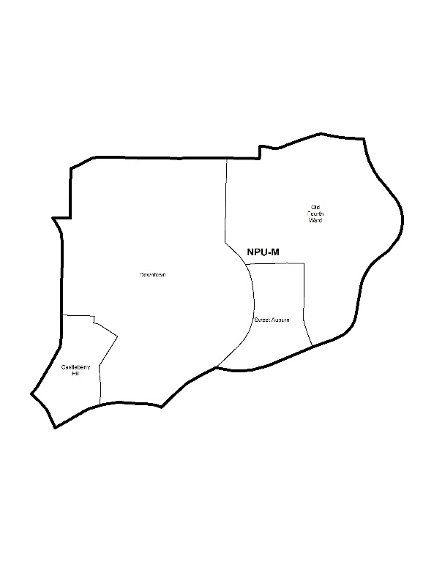

NEIGHBORHOOD PLANNING UNIT – M

MEETING INFO
Date & Time: Monday, September 24, 2018 – 6:15 PM
Location: Loudermilk Conference Center
40 Courtland Street NE Atlanta, GA 30303
CONTACT INFO
Derek Matory, NPU-M, Chairperson – (404) 784-0814 or chair@npumatlanta.org
Jon McKenley, City of Atlanta, Planner – (404) 546-0158 or jmckenley@AtlantaGa.Gov
Erica Pines, City of Atlanta, Asst. Director – (404) 546-0159 or epines@AtlantaGa.Gov
Keyetta Holmes, City of Atlanta, Interim Director – (404) 546-0166 or kmholmes@AtlantaGa.Gov

AGENDA
1. Opening Remarks/Introductions 6:25pm
2. Approval of Minutes Approved
3. Announcements
4. Reports from City Departmental Representatives
5. Comments from Elected Officials
6. Presentation(s)
- Jackson Street Bridge Update: Jonathan DiGiola
- Bylaws Committee: Kipp Dunlap
- 2019 NPU M Leadership Team
7. Planner’s Report
8. Committee Reports
9. Matters for Voting

Special Event Application(s) – MOSE
Event Name | Event Organizer | Event Location | Event Date
Germany Day in Atlanta Light Art Festival  Motion to Support: Approved | Miriam Bruns & Paulina Guzman | Atlanta Central Library | October 5, 2018

Added to Agenda: Taste of Atlanta – Motion of Support

Liquor License Application(s) – LRB
Name of Business | Type of Business | Applicant | Property Address | Request
Legal Seafoods  Motion to Support: Approved | Restaurant | Michele Magnifico | 275 Baker Street NW | Change of Agent
Root Baking  Motion to Support: Approved | Cafe | Christopher R. Wilkins | 875 Ponce de Leon Avenue NE | New Business
Dad’s Garage Theatre Company  Asked to be Deferred | Non-Profit Theatre | Lara Smith | 569 Ezzard Street | Adding Patio
Fresh to Order  Motion to Support: Approved | Restaurant | Pierre Panos | 1 CNN Center | Change of Licensee
Coca Cola Plaza  Motion to Support: Approved | Restaurant | Matthew E. Watts | 1 Coca Cola Plaza | Change of Agent
Day Dreams  Motion to Defer: Approved | Restaurant | DMC Hookah Lounge LLC | 257 Trinity Avenue SW | Change of Ownership

Text Amendment(s) – Zoning Ordinance
Legislation | Public Hearing
Z-18-83 Motion to Support: Approved  An Ordinance to amend the 1982 Atlanta Zoning Ordinance, as amended, City of Atlanta Code of Ordinances part 16, so as to add a new Chapter 16A entitled I-Mix (Industrial Mixed-Use) District; to define certain areas and for other purposes. FACT SHEET | Zoning Review Board – City Hall Council Chambers | October 4 or 11, 2018
Z-18-100 (Review and Comment Only)  An Ordinance to amend the Zoning Ordinance of the City of Atlanta (Part 16), as amended, by amending and clarifying various provisions of the text of the Zoning Ordinance, including individual zoning district regulations, with regard to the subject areas and provisions that follow: Accessory Dwellings (Section 1 below); Definitions (Section 2 below); Uses in Industrial Districts (Section 3 below); Loading Requirements (Section 4 below); MRC Residential Density (Section 5 below); New Multi-Unit Housing Zoning District and Regulations (Section 6 below); Parking (Section 7 below); Neighborhood Design Standards (Section 8 below); Telecommunications (Section 9 below); Transitional Height Planes (Section 10 below); and Quality of Life Districts (Section 11 below); to amend multiple sections of the Zoning Ordinance related to bicycle parking requirements so as to coordinate with certain cross references in Ordinance number 18-O-1023 (Z-17-93) and correct certain scrivener’s errors therein (Section 12); to repeal conflicting laws; and for other purposes. FACT SHEET, INFORMATIONAL BOOKLET | Zoning Review Board – City Hall Council Chambers | November 1 or 8, 2018

Item V-18-20: 551 Ponce De Leon – Motion of Support: Approved

10. Old Business
11. New Business
12. Adjournment

City of Atlanta Code of Ordinances
(Campaigning by Elected Officials & Candidates)
As we prepare for 2018 Elections please allow this message to serve as a reminder of the City of Atlanta’s Code of Ordinances. Voting will involve municipal, county and state elections. The Guidelines for campaigning by elected officials at NPU and APAB meetings is strictly prohibited by the City of Atlanta‘s Code of Ordinances. Please note the following code section:

SEC. 6-3019 Prohibition of Political Forums
Part 1, Chapter 6, Article 1, Section 6-1: “It shall be unlawful for any person to use the interior of city hall, its rooms or offices in any type of advertisement of commercial products and political campaigns without first obtaining express permission from the city council. This prohibition shall apply to the filming or photographing of the interior of city hall for use in such advertisements; provided, however, that nothing in this section shall be construed to prohibit the filming or photographing of the interior of city hall for news coverage purposes by newspapers, magazines and television.”

Part 6, Chapter 3, Article B, Section 6-3010: “Neighborhood Planning Unit meetings shall not be used for political forums or campaigning for city, county, state, or federal elections.”

Examples of campaigning could include, but not be limited to:
• Introduction of elected officials as political candidates in upcoming elections;
• Passing out campaigning materials and literature; and
• Conducting either of the above in city hall, its rooms or offices.
If there are any questions or concerns, please contact: Erica Pines at (404) 546-0159 or epines@atlantaga.gov .

