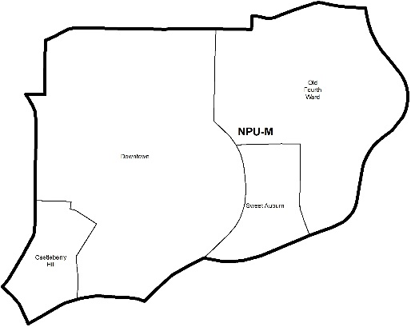

NEIGHBORHOOD PLANNING UNIT – M

MEETING INFO
Date & Time: Monday, November 26, 2018 – 6:15 PM
Location: Loudermilk Conference Center
40 Courtland Street NE Atlanta, GA 30303
CONTACT INFO
Derek Matory, NPU-M, Chairperson – (404) 784-0814 or chair@npumatlanta.org
Jon McKenley, City of Atlanta, Planner – (404) 546-0158 or jmckenley@AtlantaGa.Gov
Erica Pines, City of Atlanta, Asst. Director – (404) 546-0159 or epines@AtlantaGa.Gov
Keyetta Holmes, City of Atlanta, Interim Director – (404) 546-0166 or kmholmes@AtlantaGa.Gov

AGENDA
1. Opening Remarks/Introductions
2. Approval of Minutes
3. Announcements
4. Reports from City Departmental Representatives
5. Comments from Elected Officials
6. Presentation(s)
7. Planner’s Report
8. Committee Reports
9. Matters for Voting

Liquor License Application(s) – LRB
Name of Business | Type of Business | Applicant | Property Address | Request
Day Dreams  (Vote Required) | Restaurant | DMC Hookah Lounge LLC | 257 Trinity Avenue SW | Change of Ownership
The Loft at Castleberry Hill  (Vote Required) | Restaurant | Zane Craig Major | 170 Northside Drive SW | Change of Agent
Paschal’s Restaurant  (Vote Required) | Restaurant | Zane Major | 180 Northside Drive SW | Change of Agent
The Commerce Club  (Vote Required) | Restaurant | Caroline Hubbard | 191 Peachtree Street NE | Change of Agent
BRK Loft Bistro  (Vote Required) | Restaurant | Petula J Toussant | 12 West Peachtree Place NW | New Business
Makimono  (Vote Required) | Restaurant | Sang Mu Yi | 99 Krog Street | Change of Ownership
Walgreens #06032  (Vote Required) | Drugstore | LaQuin Lockett | 595 Piedmont Avenue | Change of Agent
Hyatt House Atlanta Downtown  (Vote Required) | Hotel | Robert M. Belmonte, II | 431 Marietta Street NW | Change of Agent

Zoning Review Board Application(s) – ZRB
Application | Property Address | Public Hearing Date
U-18-39 (Vote Required)  Applicant seeks a special use permit to operate a hotel. | 217 Lampkin Street NE | January 3 or 10, 2018

Text Amendment(s) – Zoning Ordinance
Legislation | Public Hearing
Z-18-122 (Vote Required)  An Ordinance by Councilmembers Joyce Shepherd, Carla Smith and Cleta Winslow to amend the 1982 Atlanta Zoning Ordinance, as amended, by amending the C-1 (Community Business), C-2 (Commercial Service), C-3 (Commercial Residential), C-4 (Central Area Commercial Residential), C-5 (Central Business Support), I-1 (Light Industrial), and I-2 (Heavy Industrial) zoning districts so as to require a 1,500 foot distance between service stations; and for other purposes. FACT SHEET | Zoning Review Board  City Hall Council Chambers  55 Trinity Avenue, 2nd Floor, City Hall | December 6 or 13, 2018

Proposed Legislation – Atlanta City Council
Legislation | Public Hearing
18-O-1299 (Information Only)  A substitute ordinance by Finance/Executive Committee amending Chapter 20, Article III, Division 1, Section 30-62 Administrative Fee Amounts – Tax Rate Structure of the City of Atlanta Code of Ordinances to increase certain fees related to occupational and business licensing; and to direct that the revenue from the fees be deposited into the accounts set forth herein; and for other purposes. | Finance/Executive Committee – City Hall Committee Room #1 | November 28, 2018

10. Old Business
11. New Business
12. Adjournment

City of Atlanta Code of Ordinances
(Campaigning by Elected Officials & Candidates)
As we prepare for 2018 Elections please allow this message to serve as a reminder of the City of Atlanta’s Code of Ordinances. Voting will involve municipal, county and state elections. The Guidelines for campaigning by elected officials at NPU and APAB meetings is strictly prohibited by the City of Atlanta‘s Code of Ordinances. Please note the following code section:

SEC. 6-3019 Prohibition of Political Forums
Part 1, Chapter 6, Article 1, Section 6-1: “It shall be unlawful for any person to use the interior of city hall, its rooms or offices in any type of advertisement of commercial products and political campaigns without first obtaining express permission from the city council. This prohibition shall apply to the filming or photographing of the interior of city hall for use in such advertisements; provided, however, that nothing in this section shall be construed to prohibit the filming or photographing of the interior of city hall for news coverage purposes by newspapers, magazines and television.”

Part 6, Chapter 3, Article B, Section 6-3010: “Neighborhood Planning Unit meetings shall not be used for political forums or campaigning for city, county, state, or federal elections.”

Examples of campaigning could include, but not be limited to:
• Introduction of elected officials as political candidates in upcoming elections;
• Passing out campaigning materials and literature; and
• Conducting either of the above in city hall, its rooms or offices.
If there are any questions or concerns, please contact: Erica Pines at (404) 546-0159 or epines@atlantaga.gov .

