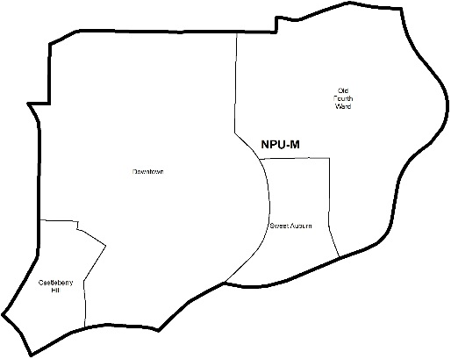

NEIGHBORHOOD PLANNING UNIT – M

MEETING INFO
Date & Time: Monday, December 10, 2018 – 6:15 PM
Location: Southface Energy Institute
241 Pine Street NE Atlanta, GA 30308
CONTACT INFO
Derek Matory, NPU-M, Chairperson – (404) 784-0814 or chair@npumatlanta.org
Jon McKenley, City of Atlanta, Planner – (404) 546-0158 or jmckenley@AtlantaGa.Gov
Erica Pines, City of Atlanta, Asst. Director – (404) 546-0159 or epines@AtlantaGa.Gov
Keyetta Holmes, City of Atlanta, Interim Director – (404) 546-0166 or kmholmes@AtlantaGa.Gov

AGENDA
1. Opening Remarks/Introductions 6:25pm
2. Approval of Minutes Unanimous Approval
3. Announcements
4. Reports from City Departmental Representatives
Mayors Office of Cultural Affairs – Mural Series:
Motion to Recommend Support: Approved
Code of Enforcement – No officer for NPU M
5. Comments from Elected Officials
6. Presentation(s)
7. Planner’s Report
8. Committee Reports
9. Matters for Voting

Liquor License Application(s) – LRB
Name of Business | Type of Business | Applicant | Property Address | Request
Makimono | Restaurant | Sang Mu Yi | 99 Krog Street | Change of Ownership
Hawkers Asian Street Fare  Motion to Support: Approved | Restaurant | Anthony S. Quirce | 661 Auburn Avenue NE | New Business
Twelve Downtown (Main and Pool Bar)  Motion to Support: Approved | Hotel | Scott A. Melchior | 400 West Peachtree Street NW | Change of Ownership
Crowne Plaza Atlanta Midtown (The Grille@590, Room Service, Lobby Bar/Lounge and Staybridge Suites Lounge)  Motion to Support: Approved | Hotel | Teresa Sims | 590 West Peachtree Street NW | Change of Agent
The Wingshack ATL  Motion to Support: Approved | Restaurant | Isla Marrero | 495 Whitehall Street | New Business

10. Old Business
11. New Business
12. Adjournment

City of Atlanta Code of Ordinances
(Campaigning by Elected Officials & Candidates)
As we prepare for 2018 Elections please allow this message to serve as a reminder of the City of Atlanta’s Code of Ordinances. Voting will involve municipal, county and state elections. The Guidelines for campaigning by elected officials at NPU and APAB meetings is strictly prohibited by the City of Atlanta‘s Code of Ordinances. Please note the following code section:

SEC. 6-3019 Prohibition of Political Forums
Part 1, Chapter 6, Article 1, Section 6-1: “It shall be unlawful for any person to use the interior of city hall, its rooms or offices in any type of advertisement of commercial products and political campaigns without first obtaining express permission from the city council. This prohibition shall apply to the filming or photographing of the interior of city hall for use in such advertisements; provided, however, that nothing in this section shall be construed to prohibit the filming or photographing of the interior of city hall for news coverage purposes by newspapers, magazines and television.”

Part 6, Chapter 3, Article B, Section 6-3010: “Neighborhood Planning Unit meetings shall not be used for political forums or campaigning for city, county, state, or federal elections.”

Examples of campaigning could include, but not be limited to:
• Introduction of elected officials as political candidates in upcoming elections;
• Passing out campaigning materials and literature; and
• Conducting either of the above in city hall, its rooms or offices.
If there are any questions or concerns, please contact: Erica Pines at (404) 546-0159 or epines@atlantaga.gov .

