
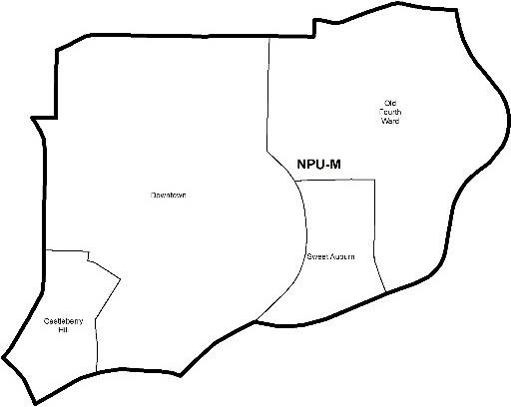
NEIGHBORHOOD PLANNING UNIT – M

MEETING INFO
Date & Time: Monday, March 25, 2019 – 6:15 PM
Location: Loudermilk Conference Center 40 Courtland Street NE Atlanta, GA 30303

CONTACT INFO
Rebecca Rice, NPU-M, Chairperson – (858) 248-1259 or chair@npumatlanta.org
Jon McKenley, City of Atlanta, Planner – (404) 546-0158 or jmckenley@AtlantaGa.Gov Erica Pines, City of Atlanta, Asst. Director – (404) 546-0159 or epines@AtlantaGa.Gov
Keyetta Holmes, City of Atlanta, Interim Director – (404) 546-0166 or kmholmes@AtlantaGa.Gov

AGENDA
- Opening Remarks/Introductions 6:17pm
- Approval of Minutes Approved
- Announcements
- Reports from City Departmental Representatives
- Comments from Elected Officials
- Presentation(s)
  - Atlanta Bicycle Coalition: Sagirah Jones
- Planner’s Report
- Committee Reports
- Matters for Voting

Special Event Application(s) – MOSE
Event Name | Event Organizer | Event Location | Event Date
13th Annual Atlanta Vision Walk  Motion of Support:  Approved | Tiffany Hoffman | Historic 4th Ward Park | April 6, 2019
MDA Muscle Walk of Greater Atlanta  Motion of Support:  Approved – conditioned on attendance @ 4th Ward West | Laura Balance | Historic 4th Ward Park | April 27, 2019
Live from Woodruff Park  Motion of Support:  Approved | Ansley Whipple | Woodruff Park | May 1-29,  2019
Atlanta Cycling Festival  Motion of Support:  Approved | LeJuano Varnell | Water Tower Park | May 11, 2019
Sweet Auburn Springfest  Motion of Support:  Approved | Deneen Johnson Jordan | Sweet Auburn District | May 11-12,  2019
The Big Bounce America  Motion of Support:  Approved | Pam Esposito | Central Park | April 26-  27,2019

Uncorked Atlanta Wine Fest  Motion of Support:  Approved | Catie Schreiman | Historic 4th Ward Park | May 18, 2019
Atlanta Caribbean Festival | Patricia Henry | Central Park | May 25-26,  2019
Atlanta Spring Wine Festival  Motion of Support:  Approved | Kari Weaver | Historic 4th Ward Park | April 13, 2019
Atlanta Summer Beer Festival  Motion of Support:  Approved | Kari Weaver | Historic 4th Ward Park | June 15, 2019
Atlanta Food and Wine Festival  Motion of Support:  Approved | Elizabeth Feichter | Historic 4th Ward Park | May 31-June 2, 2019
Dad’s Garage Big Stupid Parking Lot Carnival  Motion of Support:  Approved | Lara Smith | Dad’s Garage Theatre 569 ezzard Street SE | April 6, 2019

Liquor License Application(s) – LRB
Name of Business | Type of Business | Applicant | Property Address | Request
Blackbird  Motion of Support:  Approved | Restaurant | Asa Fain | 393 Marietta Street NW | New Business
Springhill Suites Atlanta Downtown  Motion of Deferral:  Approved | Hotel | Melissa Turner | 239 Ivan Allen Junior Boulevard | Change of Agent
Greenhouse Restaurant and Bar  Motion of Deferral:  Approved | Restaurant | Montoya Fulton | 554 Piedmont Avenue | New Business
Solora Restaurant and Music Room  Motion of Deferral for 1 Cycle:  Approved | Restaurant | Tariku Mamo  Besher | 183 Forsyth Street | New Business
Krab Queenz  Motion of Support:  Approved | Restaurant | Keneesha Bonne | 529 Peachtree Street | New Business
Park Bar  Motion of Support:  Approved | Restaurant | Matthew Tainow | 150 Walton Street | Additional Facility

Board of Zoning Adjustment Application(s) – BZA
Application | Property Address | Public Hearing Date
V-19-41  Applicant seeks a variance from the zoning regulation to 1) reduce the required front yard setback from 30 feet to 24 feet, 5 inches and 2) reduce the required half depth front yard setback  from 15 feet to 10 feet – to erect a new duplex.  Motion of Support:  Approved | 550 Highland Avenue NE | April 11, 2019

Zoning Review Board Application(s) – ZRB
Application | Property Address | Public Hearing Date
Z-19-13  Applicant seeks to rezone the 9,868 square foot property from the R-5 (Two-family residential, minimum lot size .17 acres) zoning designation to the MR-MU (Mixed-Use Multi-family residential)  zoning designation to introduce “Missing Middle” housing. SITE PLAN  Motion to Deny:  Approved | 547 Winton Terrace NE | April 4 or 11, 2019

Text Amendment(s) – Zoning Ordinance
Legislation | Public Hearing
Z-19-04 | Zoning Review Board – City Hall Council Chambers
An amended ordinance to amend the 1982 Atlanta Zoning Ordinance, | Zoning Review Board – City Hall Council Chambers | April 4 or
as amended, City of Atlanta Code of Ordinances Part 16, Chapter 36, | Zoning Review Board – City Hall Council Chambers | 11, 2019
Section 16-36.011, so as to amend BeltLine Overlay District | Zoning Review Board – City Hall Council Chambers
Regulations to establish development controls for data centers within | Zoning Review Board – City Hall Council Chambers
500 feet of the BeltLine corridor; and of other purposes. FACT | Zoning Review Board – City Hall Council Chambers
SHEET  Motion of Support:  Approved | Zoning Review Board – City Hall Council Chambers

Community Design Awards 2019
The Community Design Awards are a way for the NPU to recognize the buildings, public spaces, events, art, organizations, etc. that make your community a better place to live. Examples of previous Community Design Award winners include: neighborhood events, community organizations, new buildings, public art programs, individuals or organizations who have made a significant contribution to a neighborhood, public agencies working in that part of the city,
etc. Based on the nomination’s location, each nomination was assigned an NPU for voting purposes. There can only be one Community Design Award winner from each NPU regardless of the number of nominations. The NPU may also decide that none of the nominations warrant a
Community Design Award.

Congratulation to the Electric Box Painting Project on this year’s Community Design Award!

- Old Business
- New Business
- Adjournment 7:45pm

