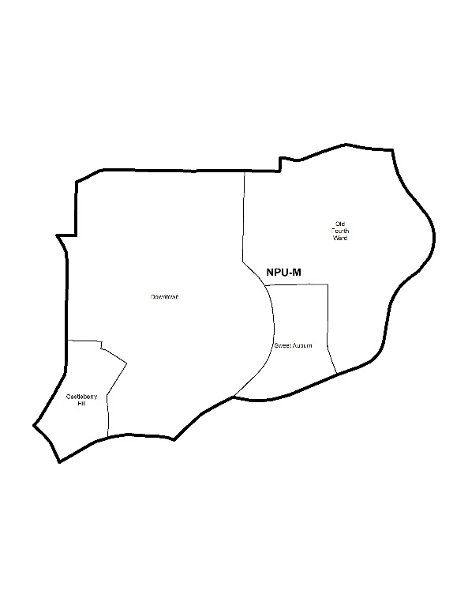

NEIGHBORHOOD PLANNING UNIT – M

MEETING INFO
Date & Time: Monday, May 13, 2019 – 6:15 PM
Location: Southface Institute
241 Pine St NE, Atlanta, GA 30308
CONTACT INFO
Rebecca Rice, NPU-M, Chairperson – (858) 248-1259 or chair@npumatlanta.org
Jon McKenley, City of Atlanta, Planner – (404) 546-0158 or jmckenley@AtlantaGa.Gov
Keyetta Holmes, City of Atlanta, Interim Director – (404) 546-0166 or kmholmes@AtlantaGa.Gov

AGENDA
1. Opening Remarks/Introductions 6:15pm
2. Approval of Minutes Approved
3. Announcements
4. Reports from City Departmental Representatives
5. Comments from Elected Officials
6. Presentation(s)
- Atlanta Bicycle Coalition: Sagirah Jones
- WeToursATL: Serena Garcia
7. Planner’s Report
8. Committee Reports
9. Matters for Voting

Special Event Application(s) – MOSE
Event Name | Event Organizer | Event Location | Event Date
Da Blackman  Motion to Not Support:  Approved  (Due to Consecutive no-shows) | Rady Williams | 70 Boulevard Avenue NE | June 10-11, 2019
Father’s Day ATL Celebration  Motion to Not Support:  Approved  (Due to Consecutive no-shows) | Yusuf A. Muhammad | 17 Jesse Hill Drive Butler Street | May 15, 2019

s

9+

Liquor License Application(s) – LRB
Name of Business | Type of Business | Applicant | Property Address | Request
Springhill Suites Atlanta Downtown  Motion to Not Support:  Approved  (Due to Consecutive no-shows) | Hotel | Melissa Turner | 239 Ivan Allen Junior Boulevard | Change of Agent
Greenhouse Restaurant and Bar  Motion to Not Support:  Approved  (Due to Consecutive no-shows) | Restaurant | Montoya Fulton | 554 Piedmont Avenue | New Business
5  Goodfellas Pizza  (Review and Comment Only) | Restaurant | Triada Kokkosis | 617-621 Spring Street | Additional Facility
Axis Replay  (Review and Comment Only) | Restaurant | Joshua David Young | 112 Krog Street NE | New Business
Bennett’s  Motion to Support:  Approved | Specialty Food Shop | Victoria Bennett Trestrail | 661 Auburn Avenue | New Business
The Cellar and The 155 Room  Motion to Support:  Approved | Convention Center | Andrew C. Tull | 200 Peachtree Street | Adding Additional Facilities
Oak at the League  Motion to Defer:  Approved | Restaurant | Vivianne Hardy Townes | 30 Ivan Allen Junior Boulevard | Change of Ownership

Board of Zoning Adjustment Application(s) – BZA
Application | Property Address | Public Hearing Date
V-19-99  Applicant seeks a variance from the zoning regulation to reduce the required front yard setback from 30 feet to 22 feet.  Motion to Support:  Approved | 581 Angier Avenue NE | June 13, 2019

Zoning Review Board Application(s) – ZRB
Application | Property Address | Public Hearing Date
Z-19-13  Applicant seeks to rezone the 9,868 square foot property from the R-5 (Two-family residential, minimum lot size .17 acres) zoning designation to the MR-MU (Mixed-Use Multi-family residential) zoning designation to introduce “Missing Middle” housing into R5 via new MR-MU. SITE PLAN  Motion to Support:  Approved | 547 Winton Terrace NE | June 6 or 13, 2019

10. Old Business
11. New Business
12. Adjournment 7:40pm

