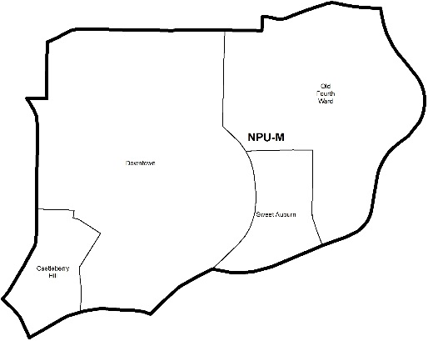

NEIGHBORHOOD PLANNING UNIT – M

MEETING INFO
Date & Time: Monday, September 23, 2019 – 6:15 PM
Location: Loudermilk Conference Center
40 Courtland Street NE Atlanta, GA 30303

CONTACT INFO
Rebecca Rice, NPU-M, Chairperson – (858) 248-1259 or chair@npumatlanta.org
Matt Adams, City of Atlanta, Planner – (404) 330-6201 or mdadams@AtlantaGa.Gov
Leah LaRue, City of Atlanta, Interim Assistant Director – (404) 330-6070 or llarue@atlantaga.gov

***2020 NPU Bylaws will be due on September 30, 2019***

AGENDA
1. Opening Remarks/Introductions 6:32pm
2. Approval of Minutes Approved
3. Announcements
4. Reports from City Departmental Representatives
5. Comments from Elected Officials

6. Presentation(s)
- Historic District Development Corporation: Chenee’ Joseph
- Georgia State University: Genya Guzeev

7. Planner’s Report

8. Committee Reports
9. Matters for Voting/Review and Comment (Applications for Review and Comment apply to subdivisions applications and applications located within 300 feet of this NPU).

Special Event Application(s) – MOSE
Event Name | Event Organizer | Event Location | Event Date
FroRibbean Fest  Will be present at General Body Meeting | Morgan Hawthorne | Central Park – Lower Field | September 28, 2019

Liquor License Application(s) – LRB
Name of Business | Type of Business | Applicant | Property Address | Request
224 Café & Restaurant  (Vote Required) | Restaurant | Sarangbe Fofana | 250 Auburn Avenue | New Business
Black Lion Café  (Vote Required) | Restaurant and Café | Abera T. Gebru | 253 Auburn Avenue | Transfer Location
Circle K #2655984  (Vote Required) | Convenience Store | Amyn A. Alidina | 160 Ted Turner Drive NW | New Business

Zoning Review Board Application(s) – ZRB
Application | Property Address | Public Hearing Date
Z-19-13  No vote taken  Applicant seeks to rezone the property from the R-5 (Two-family residential, minimum lot size .17 acres) zoning designation to the MR-MU (Mixed-Use Multi-family residential) zoning designation to introduce “Missing Middle Housing” into R-5 via new MR-MU. SITE PLAN (Amended) | 547 Winton Terrace NE | September 5 or 12, 2019
U-19-20  Motion to Recommend Support: Approved  Applicant seeks a special use permit to operate a park -for-hire facility. SITE PLAN | 428 Edgewood Avenue NE | October 10 or 17, 2019
U-19-21  Motion to Recommend Support: Approved  Applicant seeks a special use permit to operate a park -for-hire facility. SITE PLAN | 438 Edgewood Avenue NE | October 10 or 17, 2019

Text Amendment(s) – Zoning Ordinance
Legislation | Public Hearing
Z-19-76  Motion to Recommend Support: Approved  An Ordinance by Councilmember J.P. Matzigkeit to amend the 1982 Atlanta Zoning Ordinance, as amended, by amending the R-LC (Residential limited commercial district), C-1 (Community business), C-2 (Commercial service), C-3 (Commercial residential), C-4 (Central area commercial residential), C-5 (Central business support), I-mix (Industrial mixed use district), NC (Neighborhood commercial), and MRC (Mixed residential commercial) zoning districts so as to allow a “party house” as a use in some commercial zoning districts and expressly prohibit it as a use in certain districts including solely residential districts. FACT SHEET | Zoning Review Board – City Hall Council Chambers | October 10 or 17, 2019
Z-19-89  Amend SPI-1 Subarea 5 to allow LSVD signs that do not exceed 1500 sq. ft.  Motion to Recommend Support: Approved  An Ordinance by Councilmember Cleta Winslow to amend Chapter 28A (Atlanta Sign Ordinance) of Part 16 (Atlanta Zoning Ordinance) of Part III of the Code of Ordinances (Land Development Code) to allow large screen video display (LSVD) signs as a type of wall sign in Subarea 5 of the SPI-1 (Downtown Special Public Interest) zoning district; to codify such provision as 16- 28A.012(M); and for other purposes. | Zoning Review Board – City Hall Council Chambers | October 10 or 17, 2019

10. Old Business
11. New Business
12. Adjournment
City of Atlanta Code of Ordinances
(Campaigning by Elected Officials & Candidates)
Campaigning by elected officials at NPU and APAB meetings is strictly prohibited by the City of Atlanta‘s Code of Ordinances. Please note the following code section:

SEC. 6-3019 Prohibition of Political Forums
Part 6, Chapter 3, Article B, Section 6-3010: “Neighborhood Planning Unit meetings shall not be used for political forums or campaigning for city, county, state, or federal elections.”

Examples of campaigning could include, but not be limited to:
- Introduction of elected officials as political candidates in upcoming elections;
- Passing out campaigning materials and literature; and
- Conducting either of the above in City Hall, its rooms or offices.

Please contact Leah LaRue at (404) 546-0159 or llarue@atlantaga.gov with any questions or concerns.

