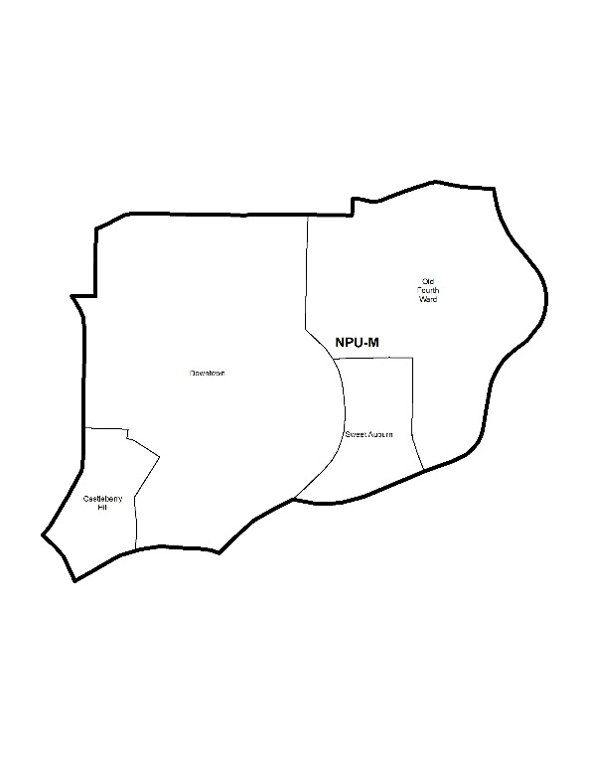

NEIGHBORHOOD PLANNING UNIT – M

MEETING INFO
Date & Time: Monday, October 28, 2019 – 6:15 PM
Location: Loudermilk Conference Center
40 Courtland Street NE Atlanta, GA 30303

CONTACT INFO
Rebecca Rice, NPU-M, Chairperson – (858) 248-1259 or chair@npumatlanta.org
Matt Adams, City of Atlanta, Planner – (404) 330-6201 or mdadams@AtlantaGa.Gov
Leah LaRue, City of Atlanta, Interim Assistant Director – (404) 330-6070 or llarue@atlantaga.gov

AGENDA
1. Opening Remarks/Introductions 6:30am
2. Approval of Minutes Approved
3. Announcements
NPU-M is taking nominations for 2020 Board positions
4. Reports from City Departmental Representatives
5. Comments from Elected Officials

6. Presentation(s)
- Navmar Foundation: Marjan Yavari
  - Motion of Support for TAD Application: Approved
- Trees Atlanta: Judy Yi
- Georgia State University: Genya Guzeev
- Grady Health Foundation of behalf of Grady Health System: Joselyn Baker
- Wingate Capital Associates, LLC: Roderick W. Teachey

7. Planner’s Report

8. Committee Reports
9. Matters for Voting/Review and Comment

Liquor License Application(s) – LRB
Name of Business | Type of Business | Applicant | Property Address | Request
224 Café & Restaurant  Motion of Support:  Approved | Restaurant | Sarangbe Fofana | 250 Auburn Avenue | New Business
Atlanta Marriott Marquis (Sear, Concierge Lounge, Pulse, High Velocity, M: Store, Pool Patio Bar)  Motion of Support:  Approved | Hotel | Meinrad F. Lang III | 265 Peachtree Center Avenue NE | Change of Agent
Courtyard by Marriott (2nd Floor and Market)  Motion of Support:  Approved | Hotel | Ivan Sidorjak | 133 Carnegie Way | Change of Agent

Text Amendment(s) – Zoning Ordinance
Legislation | Public Hearing
Z-19-89  Motion to Defer final decision to ADNA: Approved  Amend SPI-1 Subarea 5 to allow LSVD signs that do not exceed 1500 sq. ft.  An Ordinance by Councilmember Cleta Winslow to amend Chapter 28A (Atlanta Sign Ordinance) of Part 16 (Atlanta Zoning Ordinance) of Part III of the Code of Ordinances (Land Development Code) to allow large screen video display (LSVD) signs as a type of wall sign in Subarea 5 of the SPI-1 (Downtown Special Public Interest) zoning district; to codify such provision as 16- 28A.012(M); and for other purposes. | Zoning Review Board – City Hall Council Chambers | November 14, 2019
Z-19-96  Motion to Not Support: Approved*  *Conditions - If Z-19-96 is passed, exclude the following districts from legislation: SPI-1, Martin Luther King Jr. Historic/Landmark District, & Castleberry Hills  This legislation creates a definition for “small discount variety store”, and IMPOSES a distance requirement between small discount variety stores of 1,500 feet in the following zoning districts: C-1, C-2, C-3, C-4, C-5, I-MIX, I-2, SPI-1, SPI-2, SPI-9, SPI-12, SPI-15, SPI-16, SPI-17, SPI-18, SPI-20, SPI-21, SPI-22, PD-MU, PD-OC, Cabbagetown landmark district, Martin Luther King Jr. landmark district, Inman Park historic district, PRATT-PULLMAN landmark district, NC, LW, and MRC.  An Ordinance by Councilmember Marci Collier Overstreet to amend the 1982 Atlanta Zoning Ordinance, as amended, to add section 16-29.001(87) to add the definition of small discount variety store; to amend the C-1 (Community business), C-2 (Commercial service), C-3 (Commercial residential), C-4 (Central area commercial residential), C-5 (Central business support), I-Mix (Industrial mixed use district), I-2 (Heavy industrial district), SPI-1 (Downtown special public interest district), SPI-2 (Fort McPherson special public interest district), SPI-9 (Buckhead Village district), SPI-12 (Buckhead/Lenox Stations special public interest district), SPI-15 (Lindbergh Transit Station special public interest district), SPI-16 (Midtown special public interest district), SPI-17 (Piedmont Avenue special public interest district), SPI-18 (Mechanicsville Neighborhood special public interest district), spi-20 (Greenbriar special public interest district), SPI-21 (Historic West End/Adair Park special public interest district), SPI-22 (Memorial Drive/Oakland Cemetery special public interest district), PD-MU (Planned development – mixed use district), PD-OC (Planned development – office-commercial district), Cabbagetown landmark district, Martin Luther King Jr. landmark district, Inman Park historic district, Pratt-Pullman landmark district, NC (Neighborhood commercial), LW (Live work district), and MRC (Mixed residential commercial) zoning districts so as to allow small discount variety stores as a use; to require a 1,500 foot distance between small discount variety stores as defined by this ordinance; and for other purposes. FACT SHEET | Zoning Review Board – City Hall Council Chambers | November 7 or 14, 2019

Text Amendment(s) – Comprehensive Development Plan
Legislation | Property Address | Public Hearing Date
CDP-19-053  Motion to Not Support: Approved  (35 in favor; 18 opposed)  An ordinance to amend the Land Use element of the 2016 Atlanta Comprehensive Development Plan (CDP) so as to redesignate property located at 637 Willoughby Way NE from the Low Density Residential (LDR) Land Use Designation to the Medium Density Residential (MDR) Land Use Designation (Z-19-098). | 637 Willoughby Way NE | November 25, 2019  6:00 PM

10. Old Business
11. New Business
12. Adjournment Motion to Adjourn: Approved

