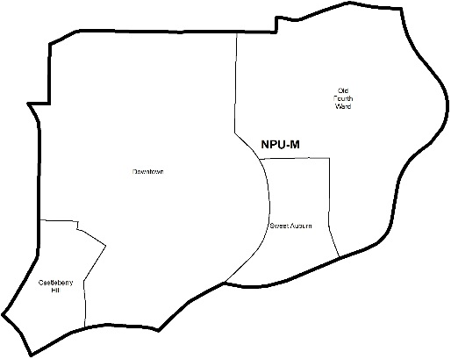

NEIGHBORHOOD PLANNING UNIT – M

MEETING INFO
Date & Time: Monday, November 25, 2019 – 6:15 PM
Location: Loudermilk Conference Center
40 Courtland Street NE Atlanta, GA 30303

CONTACT INFO
Rebecca Rice, NPU-M, Chairperson – (858) 248-1259 or chair@npumatlanta.org
Matt Adams, City of Atlanta, Planner – (404) 330-6201 or mdadams@AtlantaGa.Gov
Leah LaRue, City of Atlanta, Interim Assistant Director – (404) 330-6070 or llarue@atlantaga.gov

The Community Impact Grant Program applications will be available in January! Start thinking of innovative community projects that will help build community-centered public spaces and promote safe and thriving neighborhoods within your NPU and the city.

AGENDA
1. Opening Remarks/Introductions 6:20pm
2. Approval of Minutes Approved
3. Announcements
4. Reports from City Departmental Representatives
5. Comments from Elected Officials

6. Presentation(s)
- Department of City Planning
- Fulton County Pre-Arrest Diversion Initiative
- Community of Hospitality: Egan Short
- Partnership for Southern Equity: Andy Schneggenburger

7. Planner’s Report

8. Committee Reports
9. Matters for Voting/Review and Comment

Special Event Application(s) – MOSE
Event Name | Event Organizer | Event Location | Event Date
Three Piece Suit Football Charity Festival  Motion of Support: Approved | Cameron Miller | Historic Fourth Ward Park | February 1, 2020

Liquor License Application(s) – LRB
Name of Business | Type of Business | Applicant | Property Address | Request
Residence Inn by Marriott Atlanta Downtown  Motion of Support: Approved | Hotel | Devin D. Houston | 134 Peachtree Street NW | Change of Agent
Social Market & Café Company  Motion of Deferral for (1) Cycle: Approved | Restaurant | Mahsa S. Kimes | 57 Forsyth Street NW | New Business
Boulevard Lotto & Grocery  Motion of Support: Approved | Grocery Store | Aziz Budwwani | 371 Boulevard NE | Change of Ownership
Eurest Dining Services  Motion of Support: Approved | Restaurant | Gary L. Breneman, Jr. | 600 Peachtree Street | New Business
Big Game  Motion of Support: Approved | Restaurant | Tim Lance Catalfo | 720 Ralph McGill Boulevard | New Business
Dipped ‘N Butter Atlanta  Motion of Support: Approved | Restaurant | Jerome Robinson Scott | 480 John Wesley Dobbs Avenue NE | Change of Ownership

Zoning Review Board Application(s) – ZRB
Application | Property Address | Public Hearing Date
Z-19-98 (Vote Required)  Applicant seeks to rezone the property from the R-4 (Single-family residential, minimum lot size .21 acres) zoning designation to the MR-MU (Multi-family multi-unit) zoning designation to allow “missing middle”. SITE PLAN | 637 Willoughby Way NE | December 5, 2019

Text Amendment(s) – Zoning Ordinance
Legislation | Public Hearing
Z-19-89 (Vote Required)  Amend SPI-1 Subarea 5 to allow LSVD signs that do not exceed 1500 sq. ft.  An Ordinance by Councilmember Cleta Winslow to amend Chapter 28A (Atlanta Sign Ordinance) of Part 16 (Atlanta Zoning Ordinance) of Part III of the Code of Ordinances (Land Development Code) to allow large screen video display (LSVD) signs as a type of wall sign in Subarea 5 of the SPI-1 (Downtown Special Public Interest) zoning district; to codify such provision as 16- 28A.012(M); and for other purposes. | Zoning Review Board – City Hall Council Chambers | November 14, 2019

Text Amendment(s) – Comprehensive Development Plan
Legislation | Property Address | Public Hearing Date
CDP-19-053 (Vote Required)  An ordinance to amend the Land Use element of the 2016 Atlanta Comprehensive Development Plan (CDP) so as to redesignate property located at 637 Willoughby Way NE from the Low Density Residential (LDR) Land Use Designation to the Medium Density Residential (MDR) Land Use Designation (Z-19-098). | 637 Willoughby Way NE | November 25, 2019  6:00 PM

10. Old Business
11. New Business
12. Adjournment

