Department of City Planning | Atlanta City Hall - 55 Trinity Avenue Atlanta, GA 30303 - Suite 1450 |
(404) 330-6145 - NPUMail@AtlantaGa.Gov

NEIGHBORHOOD PLANNING UNIT – M
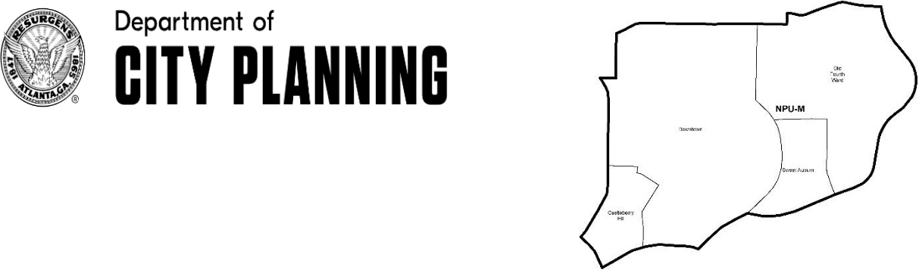

MEETING INFO
Date & Time: Monday, December 9, 2019 – 6:15 PM
Location: Southface Institute

241 Pine St NE, Atlanta, GA 30308

CONTACT INFO
Rebecca Rice, NPU-M, Chairperson – (858) 248-1259 or chair@npumatlanta.org
Matt Adams, City of Atlanta, Planner – (404) 330-6201 or mdadams@AtlantaGa.Gov

Leah LaRue, City of Atlanta, Interim Assistant Director – (404) 330-6070 or llarue@atlantaga.gov

The Community Impact Grant Program applications will be available in January! Start thinking of innovative community projects that will help build community-centered public spaces and promote safe and thriving neighborhoods within your NPU and the city.

AGENDA
- Opening Remarks/Introductions

- Approval of Minutes Approved

- Announcements

- Reports from City Departmental Representatives

- Comments from Elected Officials

- Presentation(s)
• Project Community Connections, Inc: Jimiyu Evans

- Planner’s Report

- Committee Reports

- Matters for Voting/Review and Comment


Liquor License Application(s) – LRB
 |  | Name of Business |  |  | Type of Business | Applicant | Property Address | Request
 |  | Social Market & Café Company |  |  | Restaurant | Mahsa S. | 57 Forsyth Street | New
 |  | Motion to Support: Approved |  |  | Restaurant | Kimes | NW | Business
 | Hooters of Peachtree Street (With Patio) |  |  |  | Restaurant | Cal Everett | 209 Peachtree | Change of
 |  | Motion to Support: Approved |  |  | Restaurant | Cal Everett | Street NW | Agent

Please visit the City of Atlanta Website at: www.AtlantaGa.Gov

Department of City Planning | Atlanta City Hall - 55 Trinity Avenue Atlanta, GA 30303 - Suite 1450 |
(404) 330-6145 - NPUMail@AtlantaGa.Gov
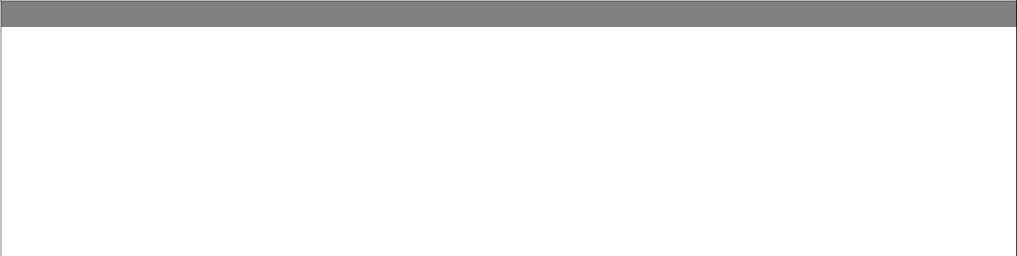

Board of Zoning Adjustment Application(s) – BZA
 | Application |  | Property Address | Public Hearing Date
 | V-19-261 (Review and Comment Only)
 | Applicant seeks a special exception from the zoning regulation to |  | 820 Ralph McGill | January 2, 2020
 | reduce the required parking spaces from 336 spaces to 221 |  | 820 Ralph McGill | January 2, 2020
 |  |  | Boulevard NE | January 2, 2020
 | spaces for a mixed-use development. |  | Boulevard NE
 | V-19-269 Motion to Defere: Approved
 | Applicant seeks a variance from the zoning regulation to 10 |  | 536 Bishops Way NE | January 9, 2020
 | reduce the west side yard setback from 15 feet to 4 feet, 2) |  | 536 Bishops Way NE | January 9, 2020
 | reduce the east side yard setback from 15 feet to 1.5 feet and 3)
 | reduce the rear yard setback from 15 feet to 1 foot.


Zoning Review Board Application(s) – ZRB
 | Application |  |  |  |  |  |  | Property Address | Public Hearing Date
 | Z-19-98 Motion to Deny Support: Approved
 | Applicant seeks to rezone the property from the R-4 (Single-
 | family residential, minimum lot size .21 acres) zoning |  |  |  |  |  |  | 637 Willoughby Way NE | December 5 or 12, 2019
 | designation to the MR-MU ((Mixed-Use Multi-family |  |  |  |  |  |  | 637 Willoughby Way NE | December 5 or 12, 2019
 | residential) zoning designation to allow for missing middle
 | housing. SITE PLAN, SURVEY
10. |  |  |  | Old Business
11. |  |  |  | New Business
12. |  |  |  | Adjournment Adjourned

Please visit the City of Atlanta Website at: www.AtlantaGa.Gov

