NEIGHBORHOOD PLANNING UNIT – M


Monday, August 24, 2020 at 6:15 PM
To join the remote meeting, click here

Meeting ID: 513 877 4717
One tap mobile +16465588656,,5138774717#

CONTACT INFORMATION
Rebecca Rice, Chairperson – 858.248.1259 or chair@npumatlanta.org

Matt Adams, City of Atlanta, Urban Planner – 404.330.6201 or mdadams@atlantaga.gov Leah LaRue, City of Atlanta, Assistant Director – 404.330.6070 or llarue@atlantaga.gov

***The Atlanta Planning Advisory Board, the support umbrella organization for NPUs, is encouraging you to register to vote and request an absentee ballot***

***2021 NPU Bylaws must be submitted by September 30, 2020. There shall be no restrictions on a resident’s right to vote on Bylaws.***

AGENDA

- Opening Remarks/Introductions

- Approval of Minutes APPROVED

- Approval of Agenda APPROVED

- Reports from City Departmental Representatives (please allow public safety representatives to report first)

- Comments from Elected Officials

- Committee Reports

- Planner’s Report

- Matters for Voting (please see attachment)

- Presentations

  - Equitable Dinners Atlanta and Out of Hand Theater: Ariel Fristoe

  - Atlanta Downtown Improvement District: Tammy Hughes

- Old Business

- New Business

- Announcements


NPU-M VOTING RULES per 2019 Bylaws

Eligible members shall be any person 18 years of age or older whose primary place of residence is within the NPU-M designated area or a representative of any corporation, organization, institution, or agency which owns property or has a place of business or profession within NPU-M designated area (Article II, Sec. II.1). All eligible members shall have one (1) vote without attendance requirements, dues payments or any other limitation (Article IV, Section IV.1).


Prepared by the Department of City Planning, City of Atlanta

55 Trinity Ave SW, Atlanta 30303 | 404.330.6070 | npumail@atlantaga.gov
13. Adjournment
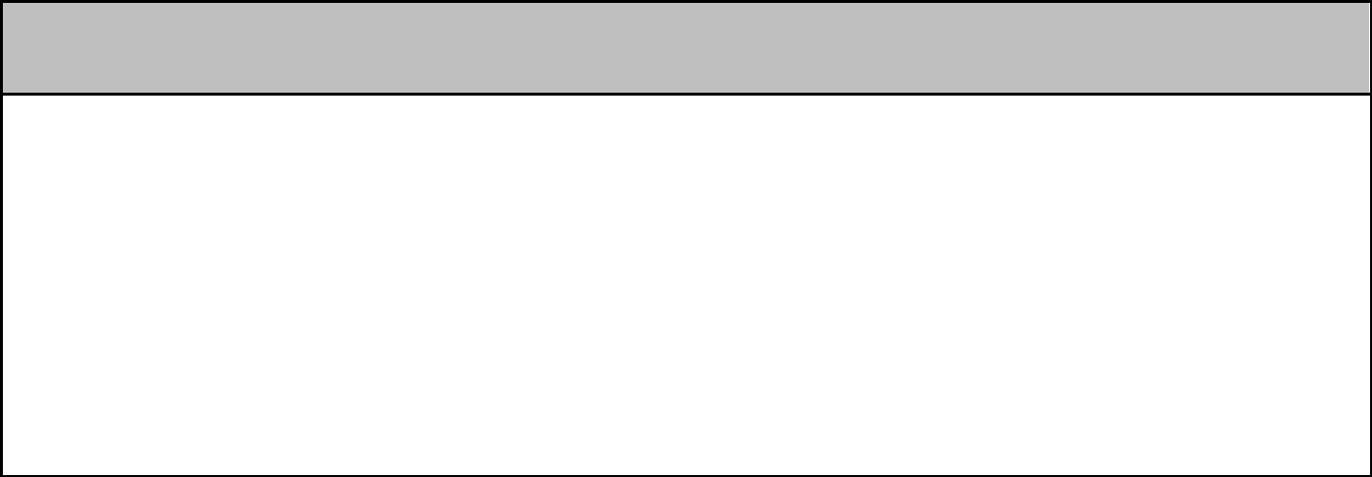

City of Atlanta Code of Ordinances
(Campaigning by Elected Officials & Candidates)

Campaigning at NPU meetings is strictly prohibited by the City of Atlanta‘s Code of Ordinances. Sec. 6-3019 Prohibition of Political Forums

“Neighborhood planning unit meetings shall not be used for political forums or campaigning for city, county, state, or federal elections.

Examples of campaigning could include, but not be limited to:
- Introduction of elected officials as political candidates in upcoming elections;

- Distributing campaign materials and literature; and

- Conducting either of the above in City Hall, its rooms or offices.

Please contact Leah LaRue at 404.546.0159 or llarue@atlantaga.gov with any questions or concerns.
MATTERS FOR VOTING

NPUs provide recommendations to the City of Atlanta by voting to support or oppose applications. The application and the NPU’s recommendations, along with Staff recommendations, are then considered by the appropriate board, association, commission, or office.


A Consent Agenda was brought to the floor to APPROVE ALL LRB Applications – MOTION TO SUPPORT: APPROVED

Alcohol License Applications (LRB)
 |  |  |  |  | Name of Business |  |  |  |  |  |  |  |  |  | Type of Business | Applicant | Property Address | Request
 |  |  |  |  |  |  | Wine Shoe |  |  |  |  |  |  |  | Wine Specialty | Krishna Chapatwala | 339 Nelson Street | Change of
 |  |  |  |  |  |  | Wine Shoe |  |  |  |  |  |  |  | Wine Specialty | Krishna Chapatwala | 339 Nelson Street | Ownership
 |  |  |  |  |  |  |  |  |  |  |  |  |  |  | Shop |  | SW | Ownership
 |  |  | REVERB by Hard Rock |  |  |  |  |  |  |  |  |  |  |  |  | Sebastian R. De La | 89 Centennial | New Business
 |  | Downtown Atlanta (Lobby |  |  |  |  |  |  |  |  |  |  |  |  | Hotel | Sebastian R. De La | Olympic Park Drive | New Business
 |  |  |  |  |  |  |  |  |  |  |  |  |  |  |  | Hoz
 |  |  |  | Bar and Rooftop Bar) |  |  |  |  |  |  |  |  |  |  |  | Hoz | NW
 |  |  |  |  |  |  |  |  |  |  |  |  |  |  |  | Lakeisha Renee | 300 Ted Turner Drive | Change of
 |  |  |  |  | Aloft Hotel Atlanta |  |  |  |  |  |  |  |  |  | Hotel | Lakeisha Renee | NW f/k/a 300 Spring | Change of
 |  |  |  |  |  |  |  |  |  |  |  |  |  |  | Hotel | Mahoney | NW f/k/a 300 Spring | Ownership
 |  |  |  |  |  |  |  |  |  |  |  |  |  |  |  | Mahoney | Street NW | Ownership
 |  |  |  |  | Bantam Pub |  |  |  |  |  |  |  |  |  | Restaurant | Tim Lance Catalfor | 737 Ralph McGill | Change of
 |  |  |  |  |  |  |  |  |  |  |  |  |  |  | Restaurant | Tim Lance Catalfor | Boulevard | Ownership
 | SkyBar at SkyView Atlanta |  |  |  |  |  |  |  |  |  |  |  |  |  | Bar | David Covell | 168 Luckie Street | New Business


Board of Zoning Adjustment Applications (BZA)
 |  | Application | Property Address | Public Hearing Date
 | V-20-72
Motion to Defer: Approved
Applicant seeks a variance from the zoning regulations to 1)
 | reduce the required front yard setback from 30 feet to 4 feet
 | and 1.5 inches, 2) reduce the required south side yard
 | setback from the required 7 feet setback 0 feet, 3) reduce
 | the required north side yard from 7 feet to 5 feet 5 inches, 4)
 | exceed the maximum lot coverage from 55 percent of the |  | 240 Lampkin Street NE | -
 | net lot area to 62 percent, 5) eliminate the neighborhood
 | design standard requiring that front entry garages be
 | recessed a minimum of 10 feet behind the front façade, 6)
 | eliminate the standard requiring a front porch that is
 | minimum 8 feet in depth and 12 feet wide and 7) exceed the
 | maximum percentage of a garage size from 35 percent of
 | the ground floor to 41 percent in order to construct a new
 | single-family residence.


Zoning Review Board Applications (ZRB)
 |  |  | Application |  | Property Address | Public Hearing Date
 | Z-19-98 (Amended)
Motion to Support: Approved
Applicant seeks to rezone the property from the R-4 (Single-family
 | residential, minimum lot size .21 acres) zoning designation to the R-4B |  |  |  | 637 Willoughby | -
 | (Single-family residential, minimum lot size .06 acres) zoning |  |  |  | Way NE
 | designation. AMENDED SITE PLAN

 | Z-20-41
Motion to Defer: Approved
Applicant seeks to rezone the .959 acre property from the MRC-2-C
 | (Mixed residential and commercial, maximum floor area ratio or 3.196
 | conditional) BeltLine Overlay zoning designation to the MRC-2-C |  |  |  |  |  |  |  |  |  |  |  |  |  |  |  |  |  | 689 Boulevard NE | -
 | (Mixed residential and commercial, maximum floor area ratio or 3.196
 | conditional) BeltLine Overlay zoning designation. ELEVATION AND
 | RENDERINGS, LANDSCAPE PLAN, SITE PLAN, SURVEY
 | Z-20-44
Motion to Defer: Approved
Applicant seeks to rezone the property from the RG-4 (General {multi-
 | family} residential, maximum floor area ratio of 1.49) zoning |  |  |  |  |  |  |  |  |  |  |  |  |  |  |  |  |  | 625 Boulevard NE | -
 | designation to the C-1 (Commercial Business) zoning designation for |  |  |  |  |  |  |  |  |  |  |  |  |  |  |  |  |  | 625 Boulevard NE
 | the construction of a Starbucks Restaurant. SITE PLAN, SURVEY
 | Z-20-46 |  |  |  |  |  |  |  |  |  |  |  |  |  |  |  |  |  | 545 Northside
 | Motion to Support: Approved  Applicant seeks to rezone the 18.57 acre property from the I-1 (Light |  |  |  |  |  |  |  |  |  |  |  |  |  |  |  |  |  | Drive NW (480 | September 4 or 14,
 | industrial) and I-2 (Heavy industrial) zoning designations to the I-MIX |  |  |  |  |  |  |  |  |  |  |  |  |  |  |  |  |  | North Avenue NW; | September 4 or 14,
 | (Industrial mixed-use district) zoning designation. SURVEY, SITE |  |  |  |  |  |  |  |  |  |  |  |  |  |  |  |  |  | 395 Northyards | 2020
 | PLAN |  |  |  |  |  |  |  |  |  |  |  |  |  |  |  |  |  | Boulevard NW)


Text Amendments – Zoning Ordinance

 |  | Legislation |  |  |  |  | Public Hearing
 | Z-20-43
Motion to Defer: Approved
An Ordinance by Councilmember Amir R. Farokhi to authorize the removal
 | of five privately owned billboard faces and their supporting structures, |  |  |  |  |  | Zoning Review
 | permitted under Part 16, Chapter 28A of the 1982 Zoning Ordinance of the |  |  |  |  |  | Board –
 | City of Atlanta, as amended, in exchange for the right given to their owners |  |  |  |  |  | City Hall Council |  | -
 | to upgrade and/or relocate five billboards where the upgrade and exchange |  |  |  |  |  | Chambers
 | may allow for the creation of the 14th Street Linear Park and the Peachtree
 | Creek at Cheshire Bridge Road Environmental Project after the five privately
 | owned sets of billboard faces and the supporting structures of relocated
 | billboards are removed; and for other purposes. OVERVIEW, FACT SHEET


Text Amendments – Comprehensive Development Plan
 | Legislation |  |  | Property Address | Public Hearing Date
 | CDP-20-23
Motion to Defer: Approved
An ordinance to amend the Land Use element of the 2016 Atlanta
 | Comprehensive Development Plan (CDP) so as to redesignate |  |  | 625 Boulevard | September 28, 2020
 | property located at |  | 625 Boulevard NE from the High Density | 625 Boulevard | September 28, 2020
 |  |  | 625 Boulevard NE from the High Density | NE | 6:00 PM
 | Residential (HDR) Land Use Designation to the Mixed Use Medium |  |  | NE | 6:00 PM
 | Density (MU-MD) Land Use Designation and for other purposes (Z-20-
044)

